INF117

Project Requirements Document

– Game Catalogue –



**Stakeholders:**

Darren Denenberg (Sponsor)

**Task Force of Game Slayers:**

Luke Duimovich(85341968)

Ulises Perez(18374947)

Matthew Sparks(42602434)

Whitney Tran(77187709)

Daniel Williams(77402284)

David Wong(22604337).

# Table of Contents

1. Project Description
   1. Service Need
   2. Project Purpose & Scope
   3. Technical Challenges / Issues
   4. Timeline
2. Requirements
   1. Functional Requirements
      1. Primary
      2. Secondary
   2. Technical Requirements
      1. Primary
      2. Secondary
   3. Usability Requirements
      1. Primary
      2. Secondary
3. Personas/Scenarios
   1. Average User Experience
   2. Admin User Experience
4. Intended Designs
   1. Front-End
      1. Sketches
      2. Before and After
   2. Back-End
      1. ER Diagram
5. Project Constraints
   1. Time Constraints
   2. Scope Constraints
6. Communication Plan
   1. Internal Communication
   2. External Communication
7. Documentation
   1. Administrative Documentation
8. References and Related Ideas

|  |  |  |  |
| --- | --- | --- | --- |
| **Document Modification History** | |  |  |
| **Version** | **Date** | **Author** | **Description** |
| **1.0** | 04/16/2018 | Whitney Tran | Initial Version |
| **1.1**  **1.12** | 04/18/2018  04/20/2018 | Matthew Sparks | Updated/added some (more) descriptions |
| **1.2** | 04/20/2018 | Luke Duimovich | Removed/changed Policy/Documentation |
| **1.3** | 04/20/2018 | Whitney Tran | Final touches of Version 1.X |
| **1.4** | 04/30/2018 | Whitney Tran  David Wong | Updated Descriptions  Added Persona/Scenario |
| **2.0** | 5/13/2018 | Whitney Tran  Matthew Sparks | Final Updates |

# Project Description

The catalogue will have a public-facing blog that will serve to display all the games within the archive. Each game will have their own detailed description along with high levels of information.

## Service Need

UCI has a vast collection of video games and there is currently no way of sharing all that accumulated knowledge and coolness with the rest of the outside world. The job is to construct a database that stores all the necessary info about each game in the collection and then design a UI/UX friendly website to display that information to users and allow them to explore the repertoire of games at UCI with ease.

## Project Purpose & Scope

The purpose of this project is to provide UCI Affiliates a location to browse the collection of donated games. The main scope is to design a site users can browse and learn about selected games.

## Technical Challenges / Issues

Designing the database since none of us are very skilled in that area. Website development might be challenging due to the same reason.

## Timeline

|  |  |
| --- | --- |
| Sketches of Front-End | Week 1-2 |
| Mockups of Basic Web | Week 3-4 |
| Learn/Start coding Web Front End | Week 5-6 |
| Design Backend | Week 7-8 |
| Continue coding front-end and connect Database | Week 9 |
| Make Final Touches to Front and Back   * get front end to look as much as possible as our mockups * if there’s time add any additional features discussed with Denenberg | Week 10 |

## Requirements

## Functional Requirements

Primary:

1. Users can browse all uploaded games.
2. Users can search for a specific game.
3. Users can filter out the search system.
4. Managers can add/delete games from the website with ease.

Secondary:

1. Users can watch video clips of the game being played.
2. Users will be able to see related games.
3. Users will be able to search by game developer/country of release.
4. Users will be able to view links to other sites with more detail.

## Technical Requirements

Primary:

1. Front-end will be simple for quick navigation and try to closely resemble our mockups.
2. Database will be stored via servers provided by UCI, file searched, or hard coded.

Secondary:

1. Landing page will include Trending/Game of the Day/Random
2. Search API will be implemented to allow for efficient sorting and searching.
3. The entire site will be interactive like a game.

## Usability Requirements

Primary:

1. The system will fully function in major browsers.
2. The system will support mobile users in some way.
3. The system will be able to store and accurately display game information.

Secondary:

1. Users will be presented a UI/UX friendly site that they will be able to efficiently browse and search through the archive of games stored on the site.

# Personas/Scenario

## Average User Experience

**Name:** Chase Wang  
**Description**: Chase is a second year student at UCI who is a casual gamer  
**Actors:** Student  
**Preconditions:** User has used catalogue like website, such as Amazon, to search for specific items.  
**Basic flow:** Chase opens up his browser and gets to the game catalogue webpage. He would like to see what games under the genre of action are in the catalogue. He taps the genre button on the left sidebar and an overlay appears on the main page with all the genres available in the database. Chase taps the Action button and all the games under the Action genre.

**Alternate flow:** Chase opens up the webpage and taps the search button. An overlay with filters and a search bar appears. Chase taps the genre filter which is a drop down selection and selects Action. All the games that are of the genre action appear underneath the search bar.

## Admin User Experience

**Name:** Denny Berg  
**Description**: A professor in UCI with permissions to add/edit the site and data.  
**Actors:** Site Moderators  
**Preconditions:** User may have some programming knowledge in Python to make changes in database and change variables.  
**Basic flow:** Denny opens up the site and is able to select any sections that has the options to edit. He clicks on an edit and can change the text within that section.  
**Alternate flow:** Chase opens up the folder with the site’s files and makes direct changes to the view.py file. Once in the editor, he can directly change the layout.

# Intended Designs

## Front-End

### Sketches

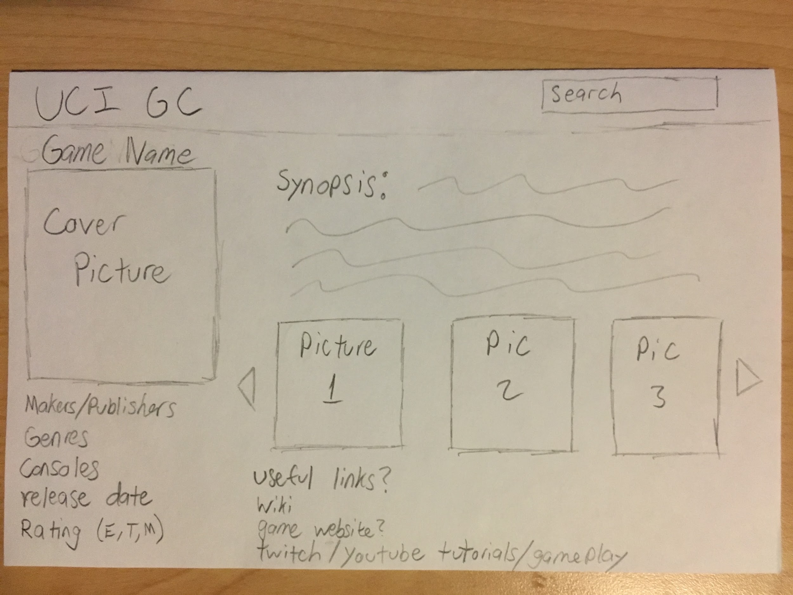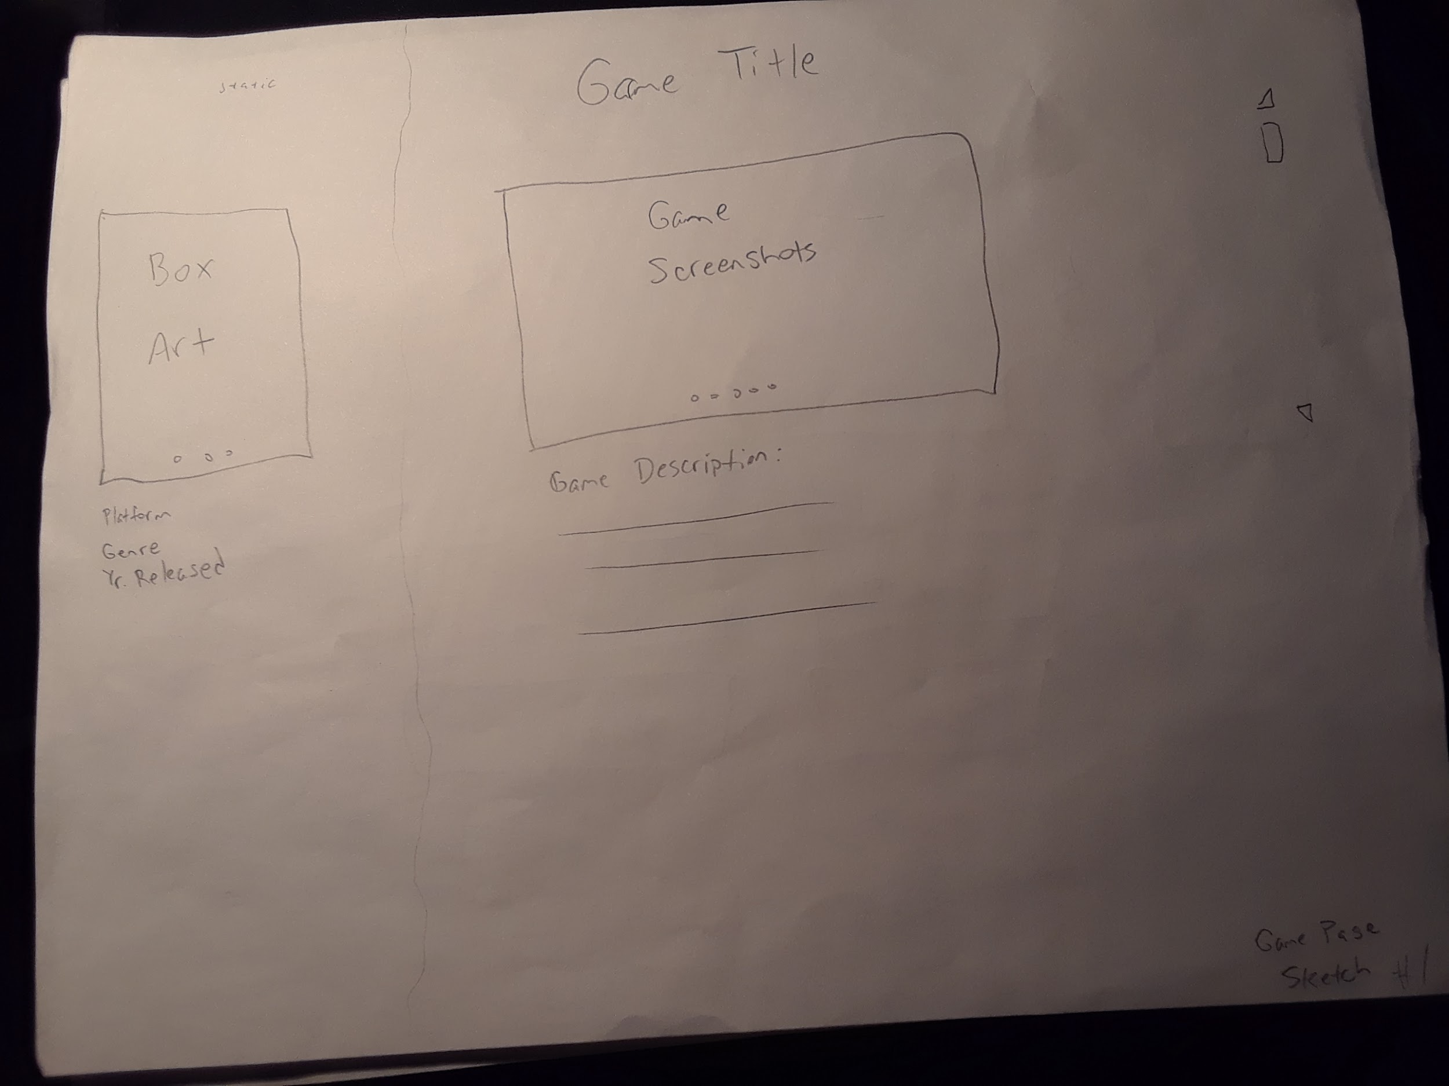

### Before and After

### 

# 

## Back-End

### ER Diagram

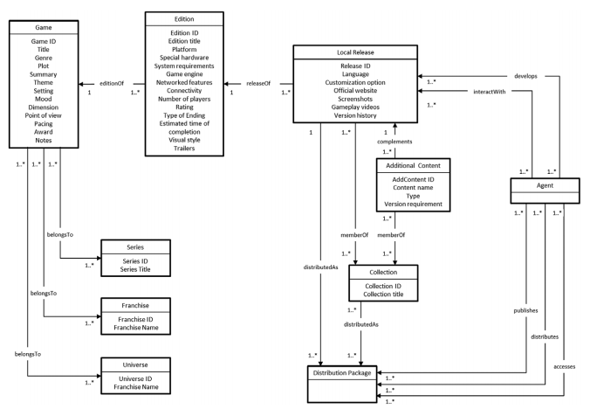

# Project Constraints

***Time constraints:*** We need either a complete design or a working prototype for the Game’s Catalogue by Week 9.

***Scope constraints:*** The project needs to not include too much information per to keep the users from getting overloaded with information. We are also going to only work with one console for now which will be the Sega Genesis.

# Communication Plan

***Internal Communication:*** Meetings will be held every Thursday or Friday at 11:00am or 10am respectively.

***External Communication:***  Announcements will be distributed via Discord, text message, email, and Slack.

# Documentation

## Administrative Documentation

Documentation and reports, such as sprint reports, will be posted about every two weeks. These reports will have updates on what has been done and what is planned to get done in the next two weeks along with some other helpful information about the website development.

# References and Related Ideas

Inspiration for web designs were taken from many websites including: Netflix, Amazon, Twitch, Gamestop, and game emulators.